

**[Dynamic Websites]**

Assignment Title:

**[Wild Swimming and Camping Website]**

Submitted To:

[Syr Kyaw Swr Thant]

Submitted By:

[Win ThawTar Htun]

[Student ID – 2021BO371]

NCC L4 DC(with BM): **Strategy First University**



**NCC Education**

**Level 4 Diploma in Computing with Business Management**

**Module Name:**

|  |
| --- |
| Centre Name : Strategy First University  Assignment Title :  Exam Cycle : Autumn 2023  Candidate Name : **Win ThawTar Htun**  NCC Education ID No. : P00195817  Submission Date : |
| Marker’s Comment :  Moderator’s Comment :  Mark: Moderated Mark : Final Mark : | |

**Statement a**

**nd Confirmation of Own Work**



**Strategy First University**

|  |
| --- |
| ***A signed copy of this form must be submitted with every assignment.***  ***If the statement is missing your work may not be marked.*** |

**Student Declaration**

I confirm the following details:

|  |  |
| --- | --- |
| Candidate Name: | Win ThawTar Htun |
| Candidate ID Number: | 00195817 |
| Unit: |  |
| Centre: | Strategy First University |
| Qualification: | Level 5 Diploma in Computing with Business Management |
| I have read and understood NCC Education’s Academic Misconduct Policy.  I confirm that this is my own work and that I have not colluded or plagiarized any part of it. | |
| Candidate Signature: | Thawdar |
| Date: | 8.8.2023 |

Table of Contents

Task1-HTML 5

Task2- CSS And Database 20

Task3- Critical Evaluation 27

Developing HTML on GWSC website 27

Developing CSS on GWSC website 28

Utilizing Web Services 28

Weather Widget 28

Location Maps 28

Communication and Send messages 29

Task4-Reflection 30

4.1 Tools and Website Development 30

4.2 Process and understanding website development 30

4.3 Future Development 31

References: 32

# Task1-HTML

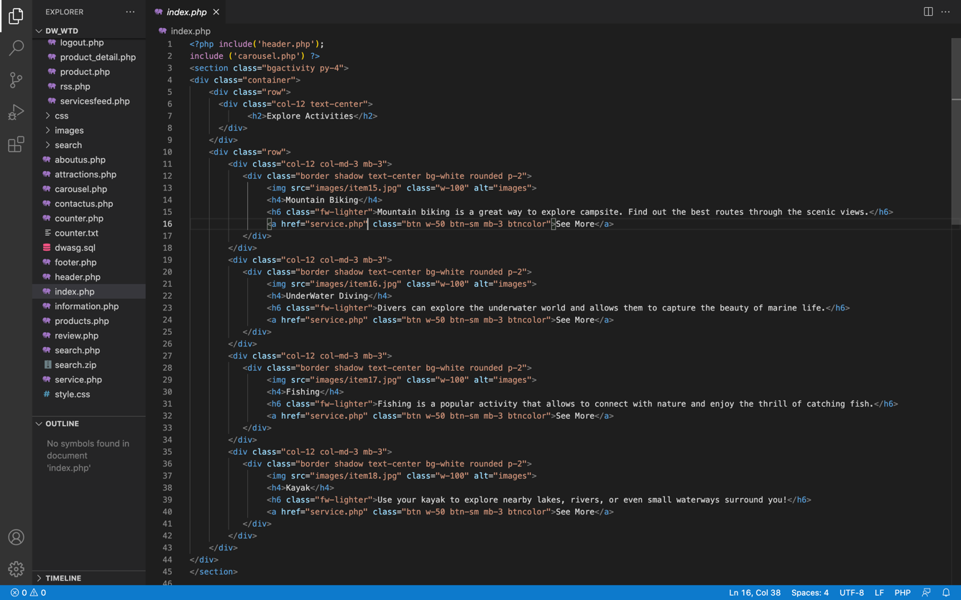

Fig 1.1 Coding Home page Index.php

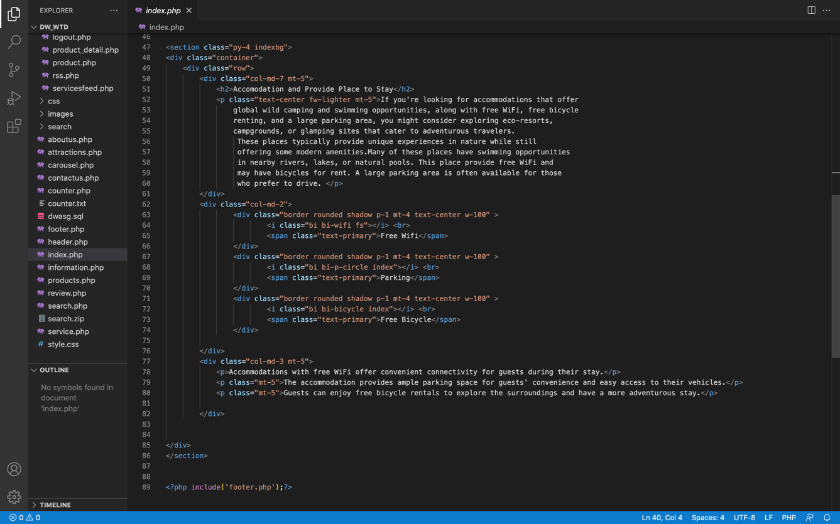

Fig 1.2 Coding Home page Index.php

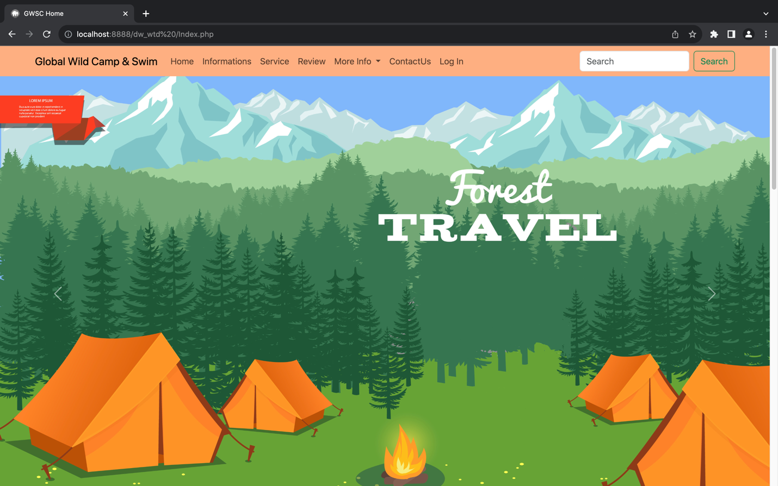

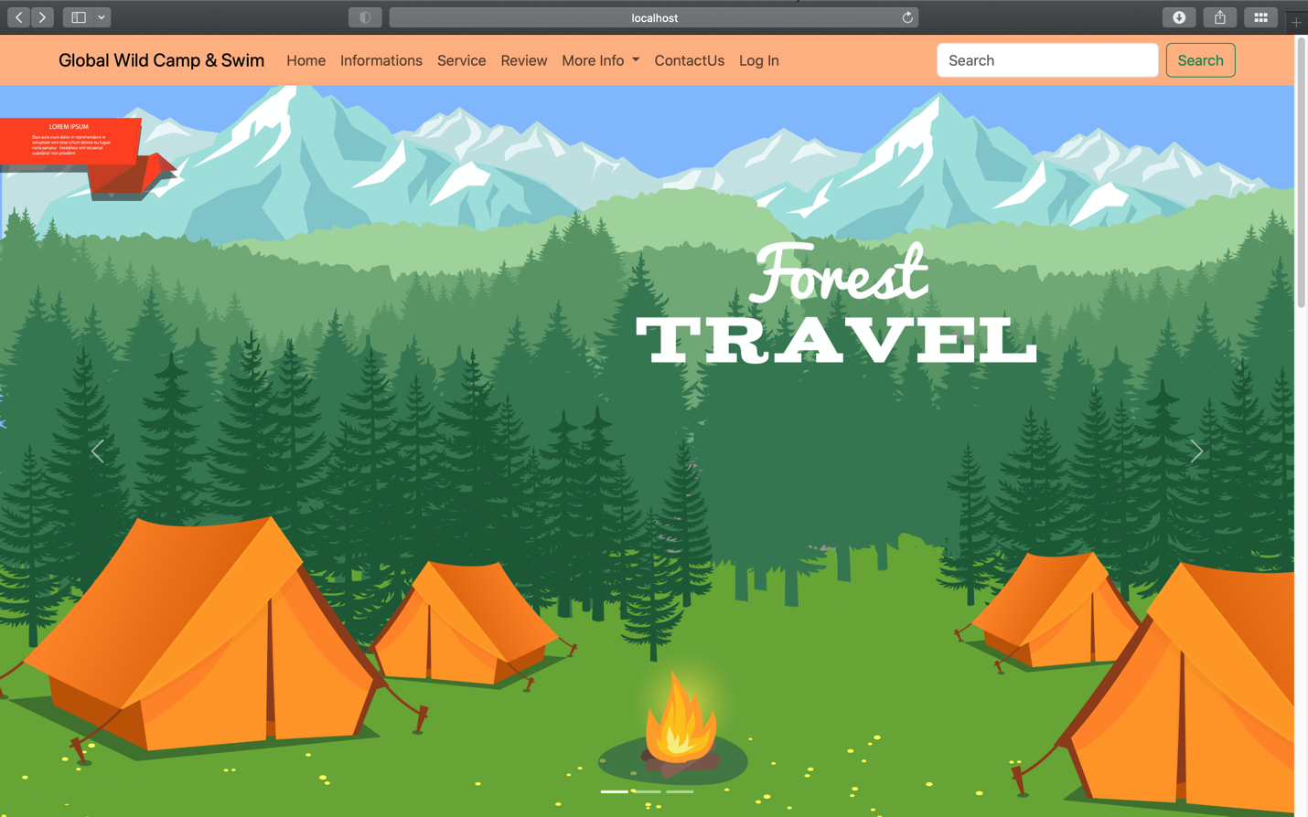

Fig 1.3-1.4 Running Global Wild Camping & Swimming website page on two web browsers

Home Page- (Chrome and Safari)

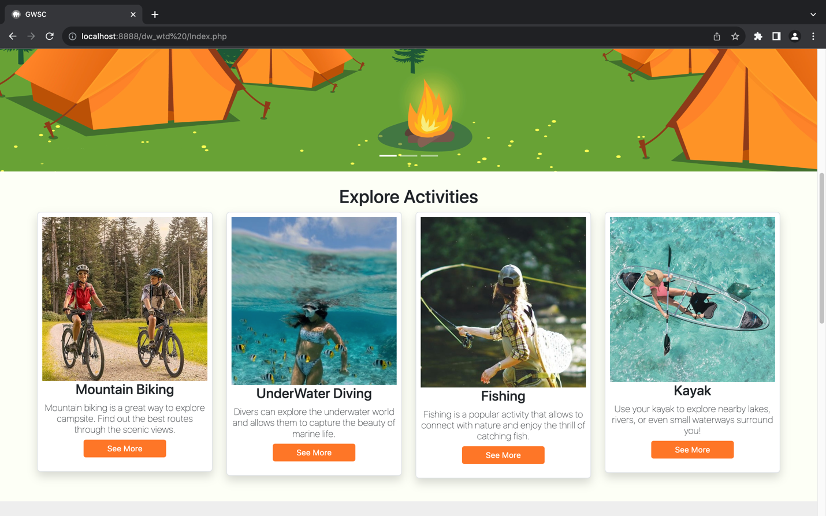

Fig 1.5 Home Page showing GWSC webpages information in slideshow and textboxes.

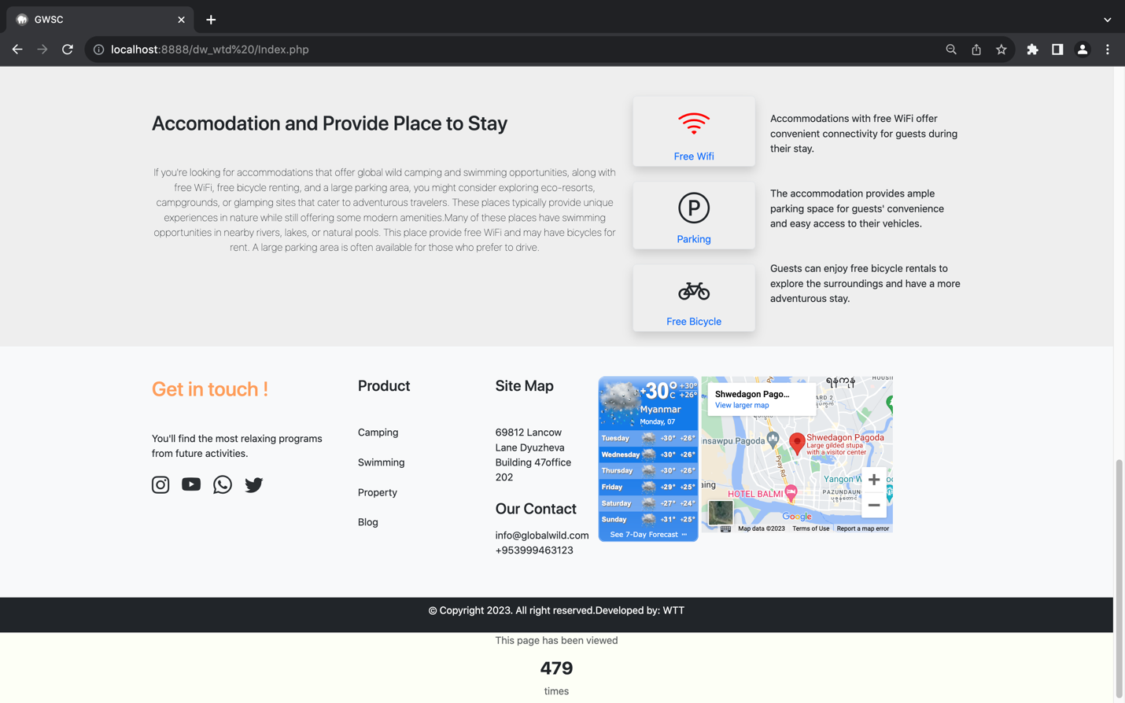

Fig 1.6 Home page pitch type interactive availability and footer.

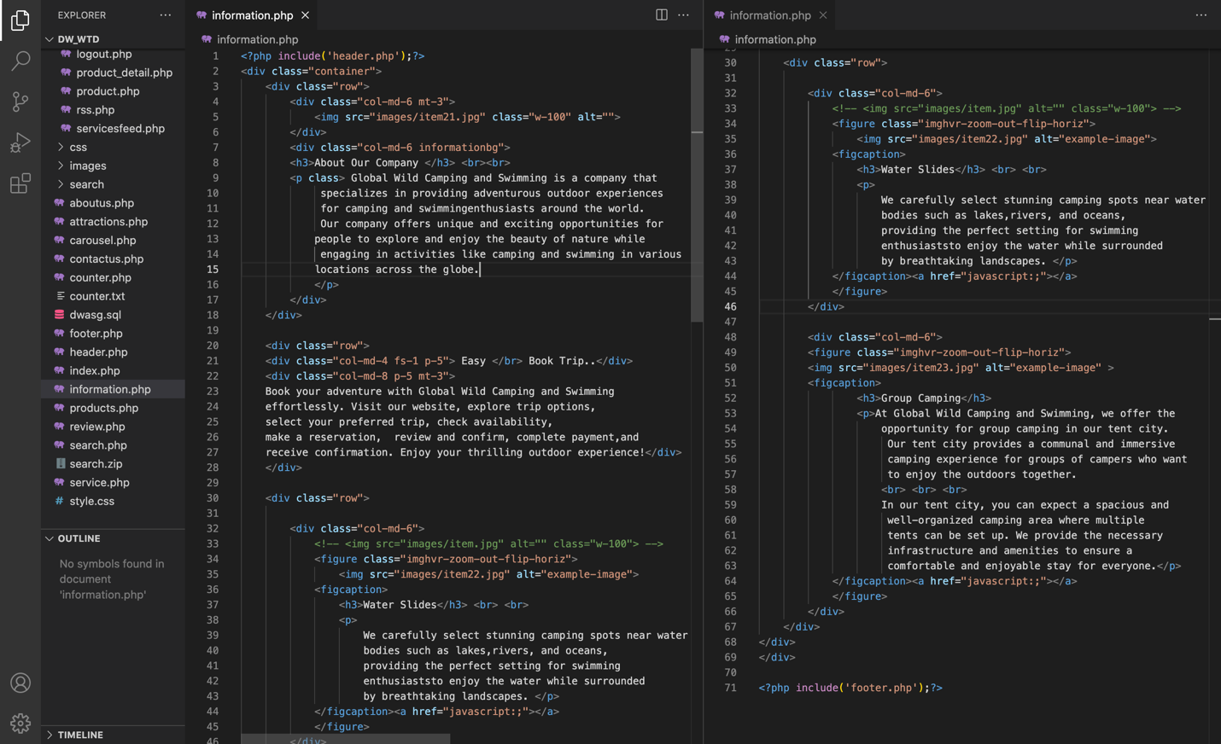

Fig 1.7 Coding GWSC page Information.php

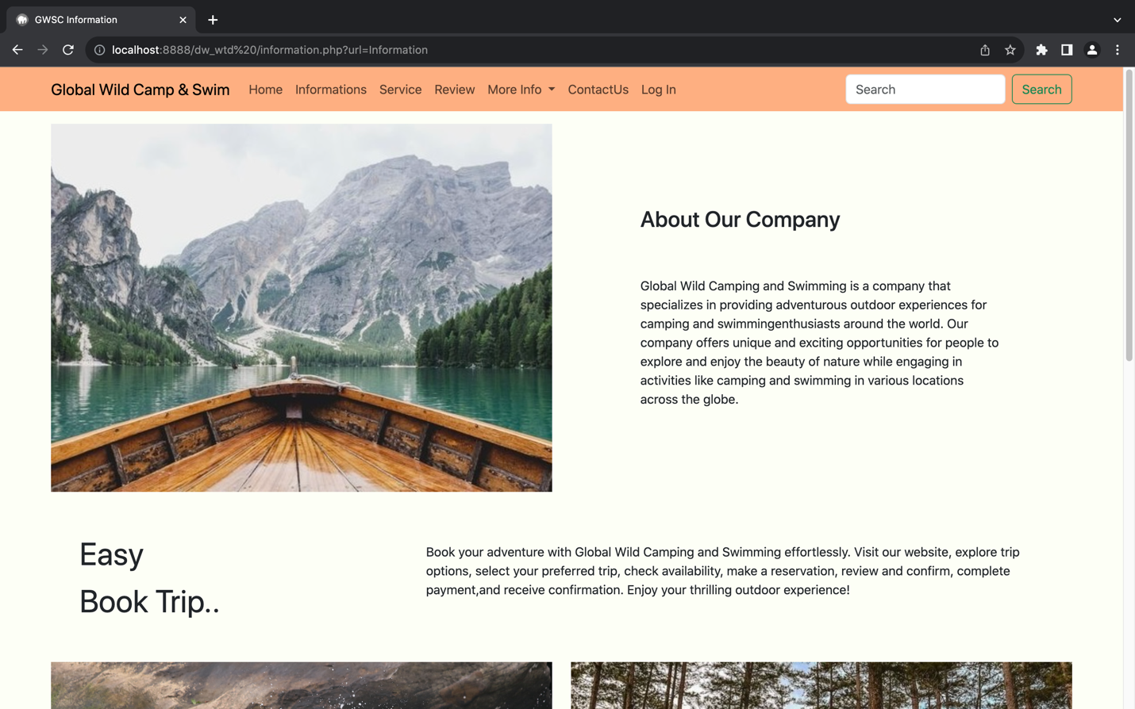

Fig 1.8 Information page

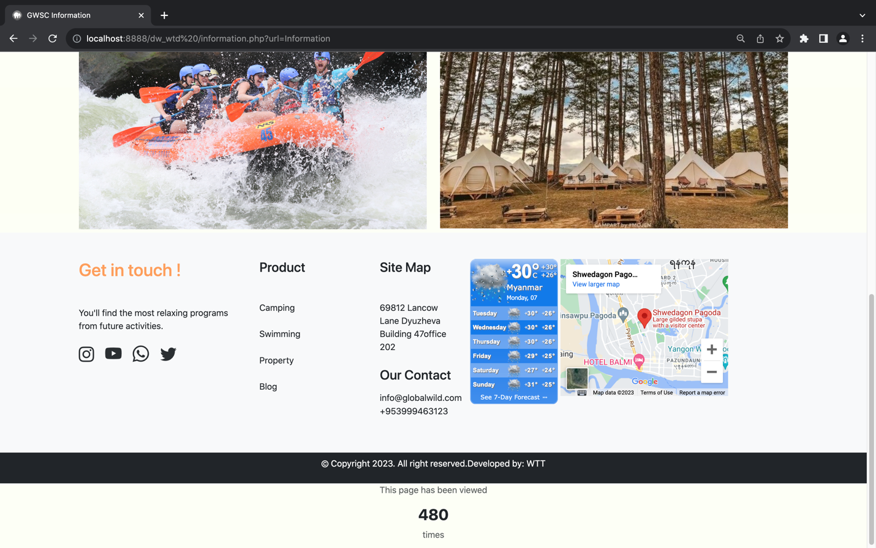

Fig 1.9 Information page along with footer.

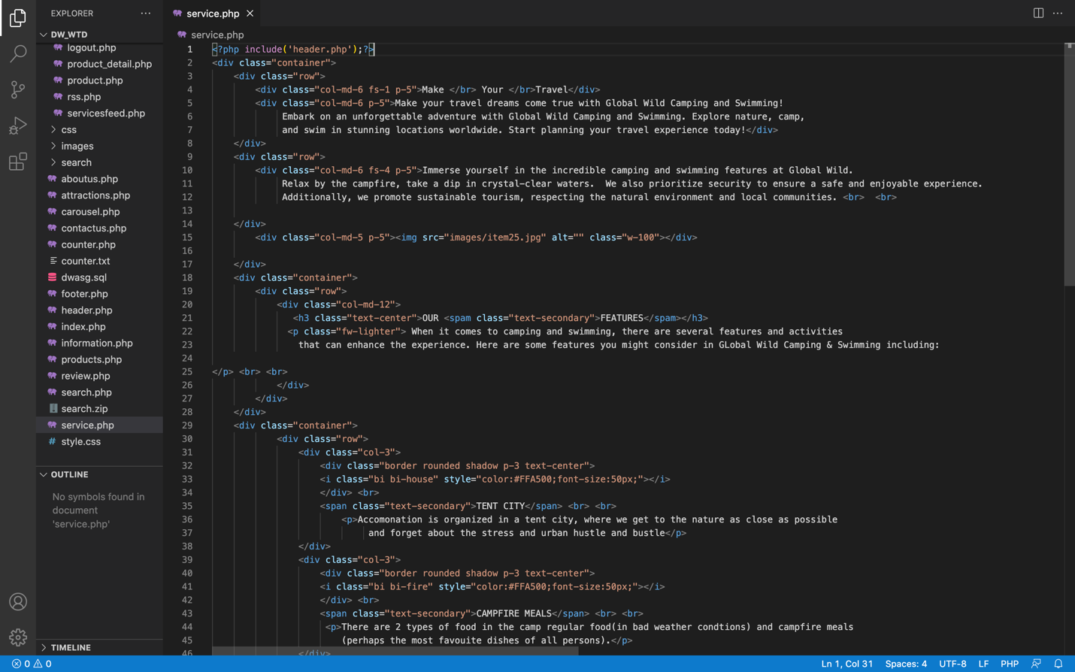

Fig 1.10 Coding GWSC service page service.php

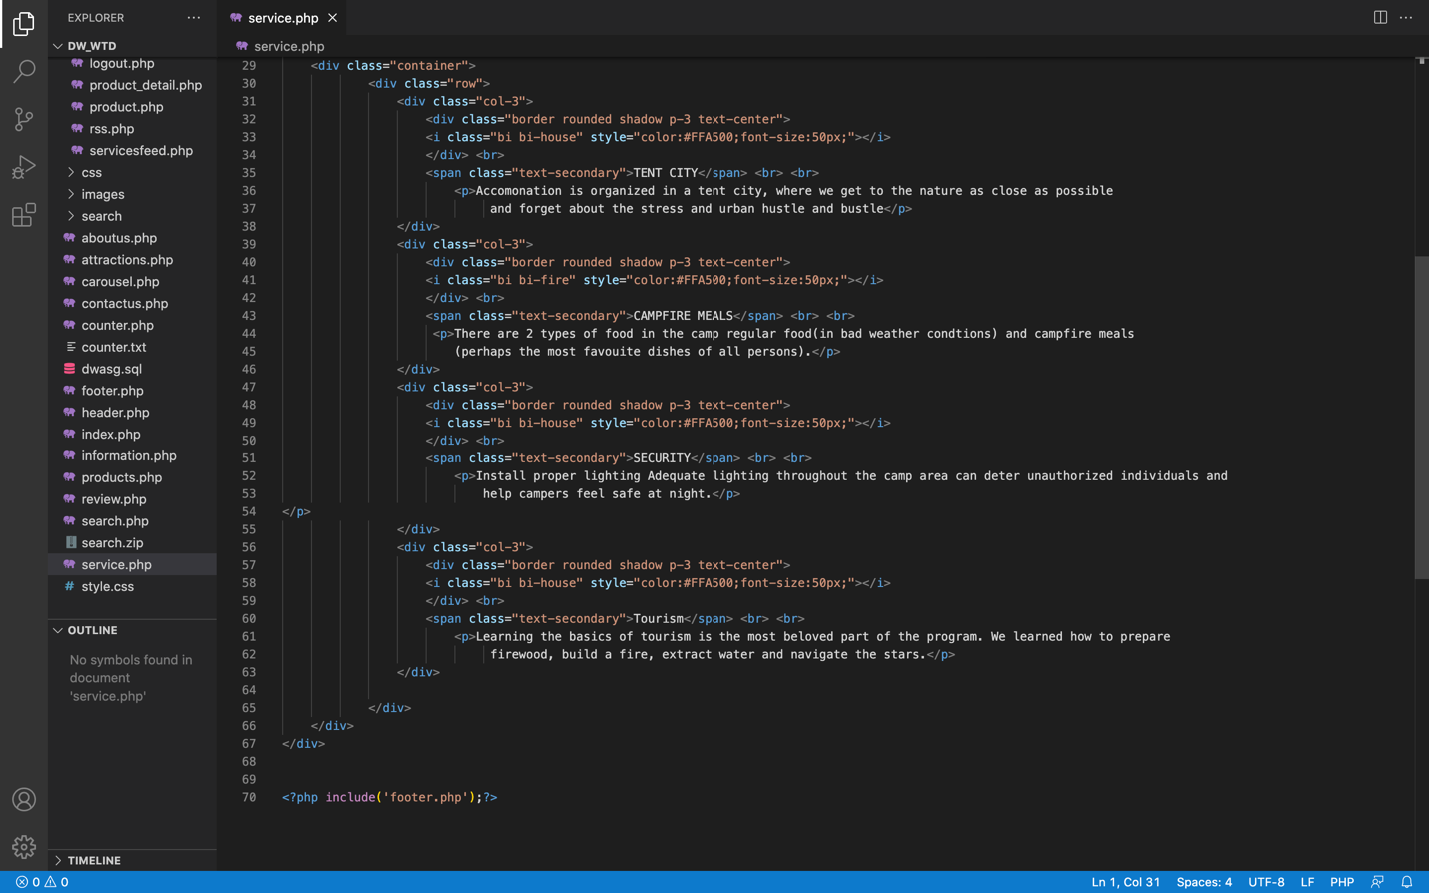

Fig 1.11 Coding GWSC service page service.php

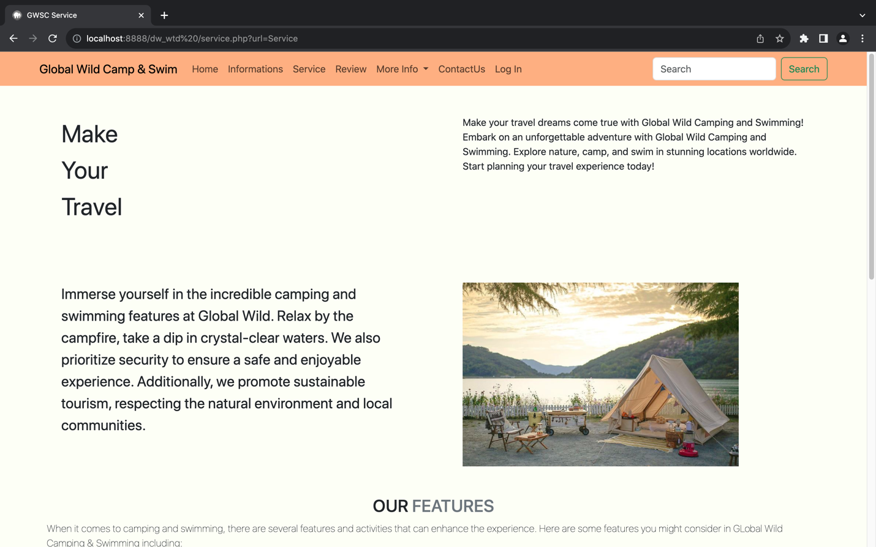

Fig 1.12 Service Page.

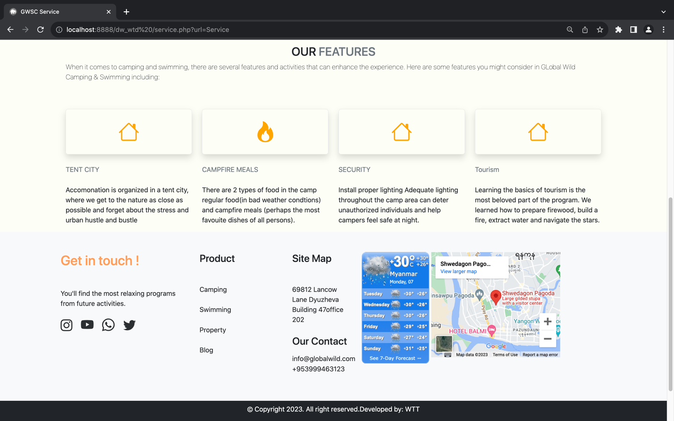

Fig 1.13 Service page.

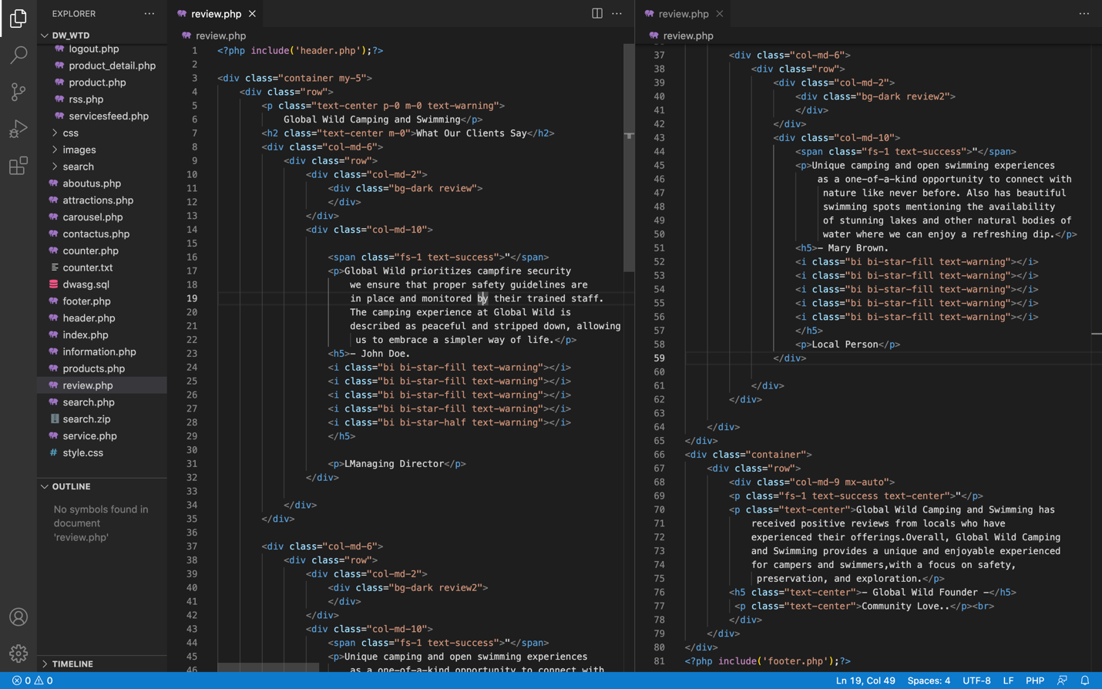

Fig 1.14 Coding GWSC review page review.php



Fig 1.15 Review Page

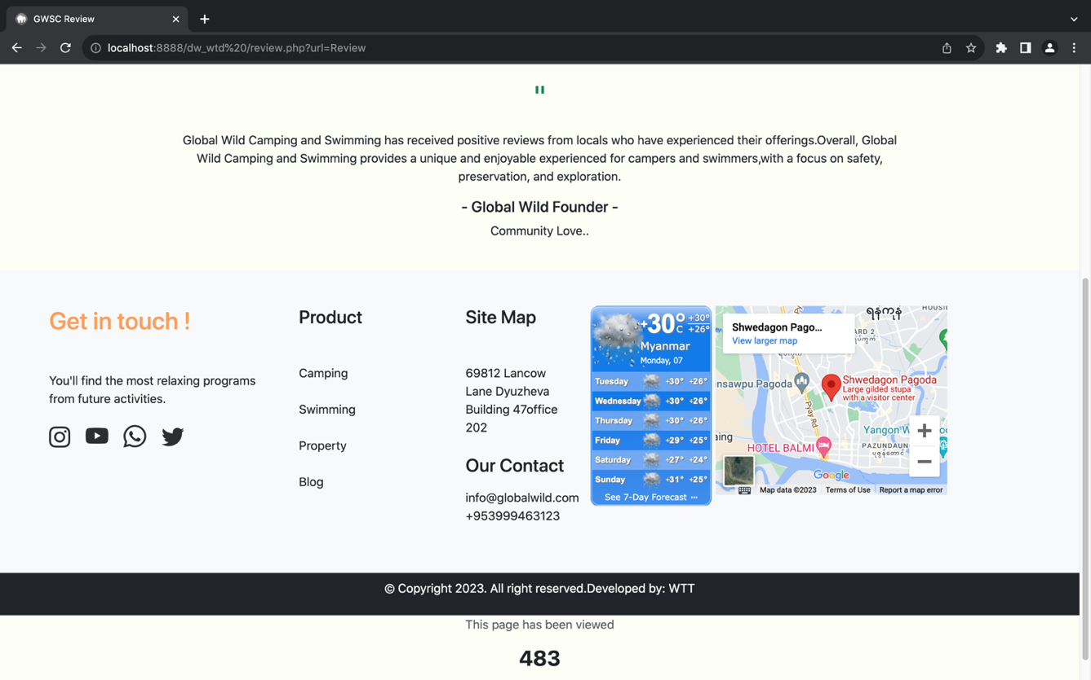

Fig 1.16 Review Page

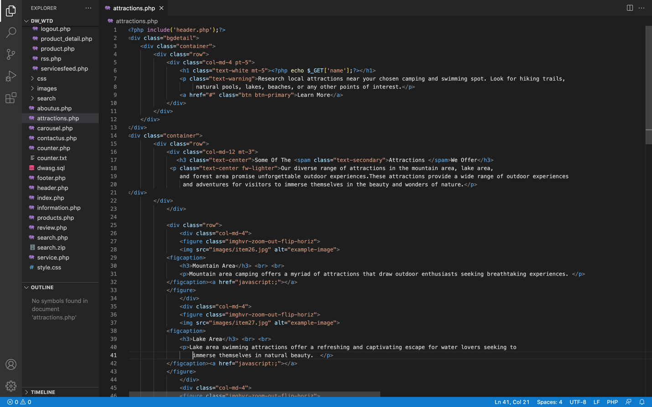

Fig 1.17 Coding Attraction Page attractions.php

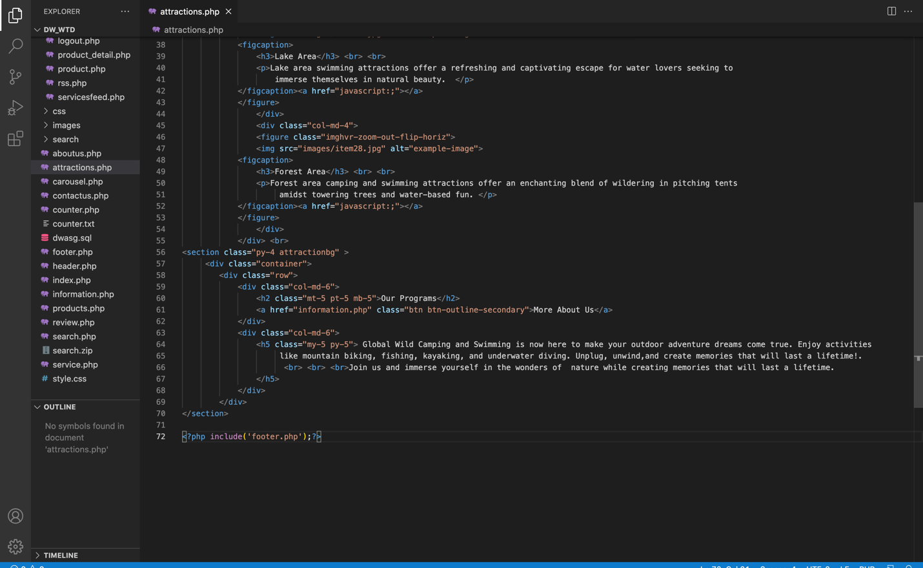

Fig 1.18 Coding Attraction Page attractions.php

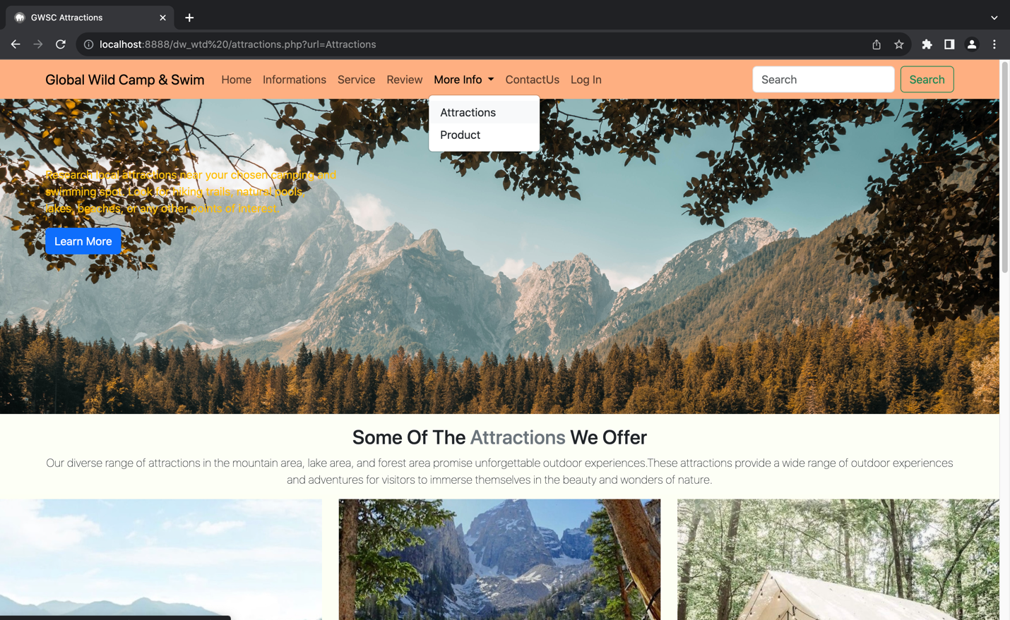

Fig 1.19 Attraction Page

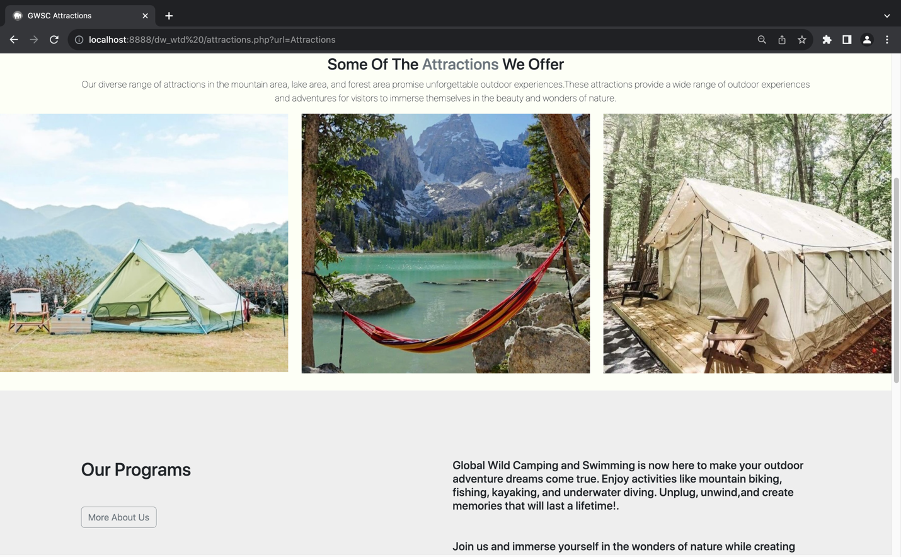

Fig 1.20 Attraction Page

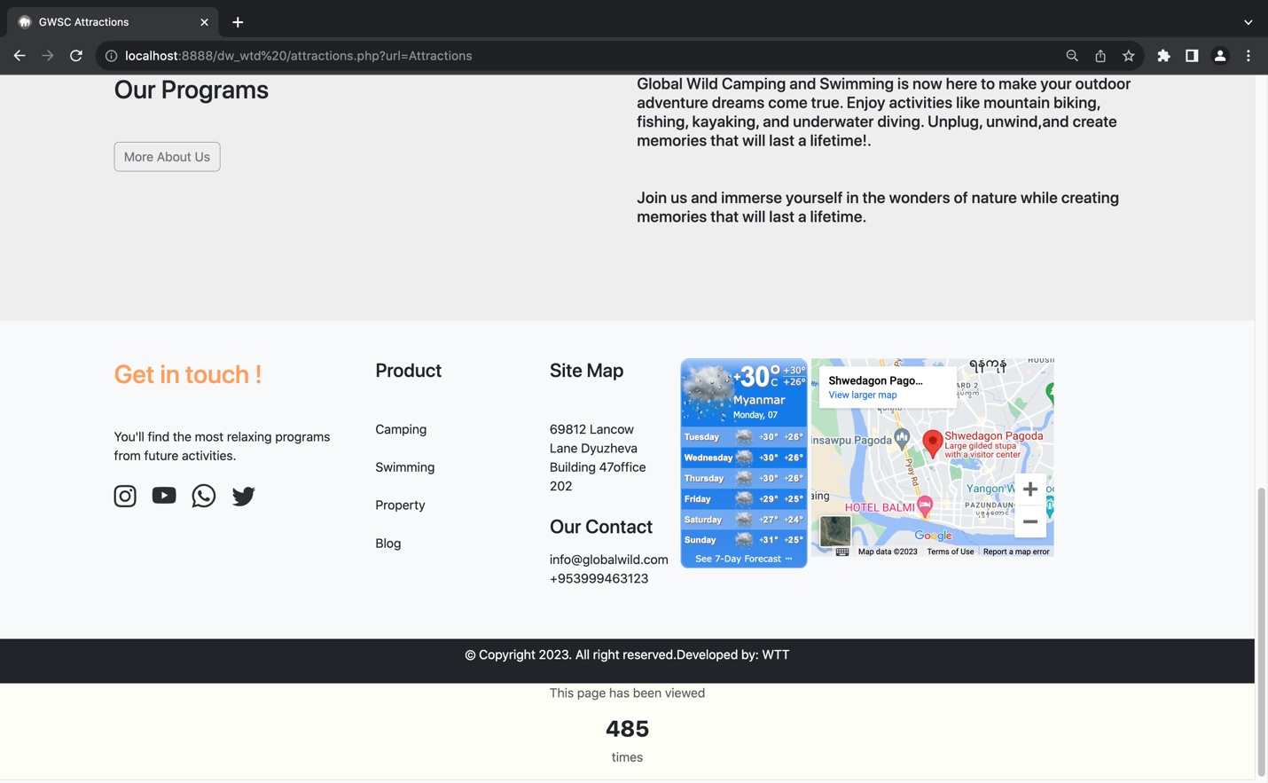

Fig 1.21 Attraction Page

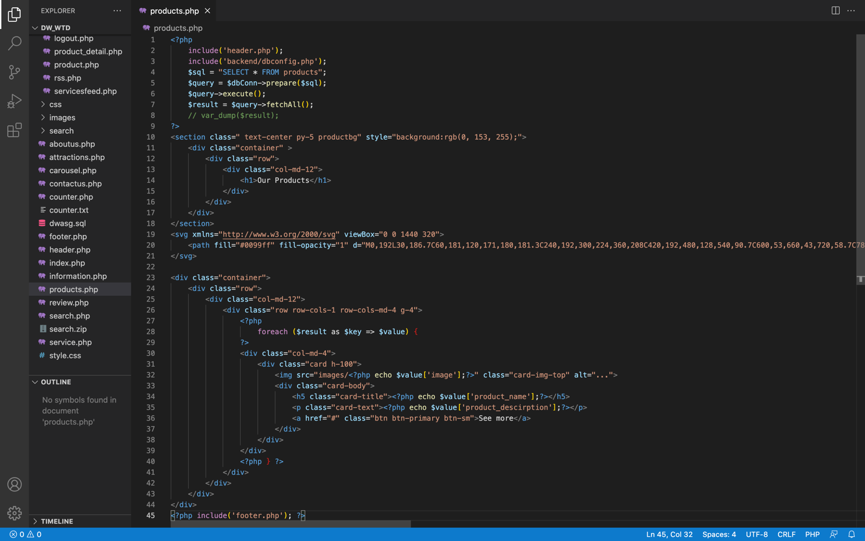

Fig 1.22 Coding Product Page products.php

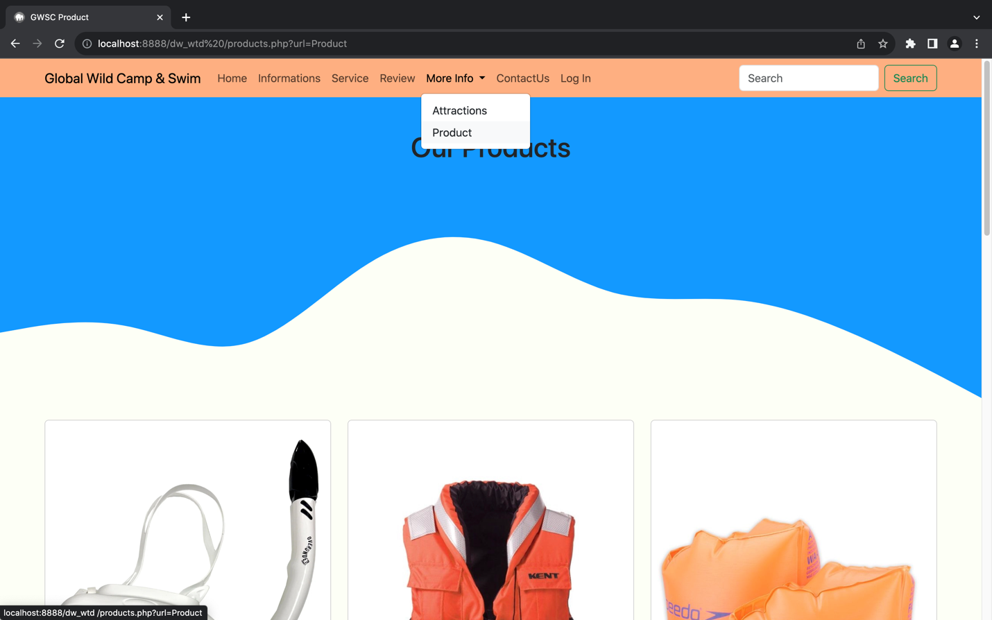

Fig 1.23 Product Page

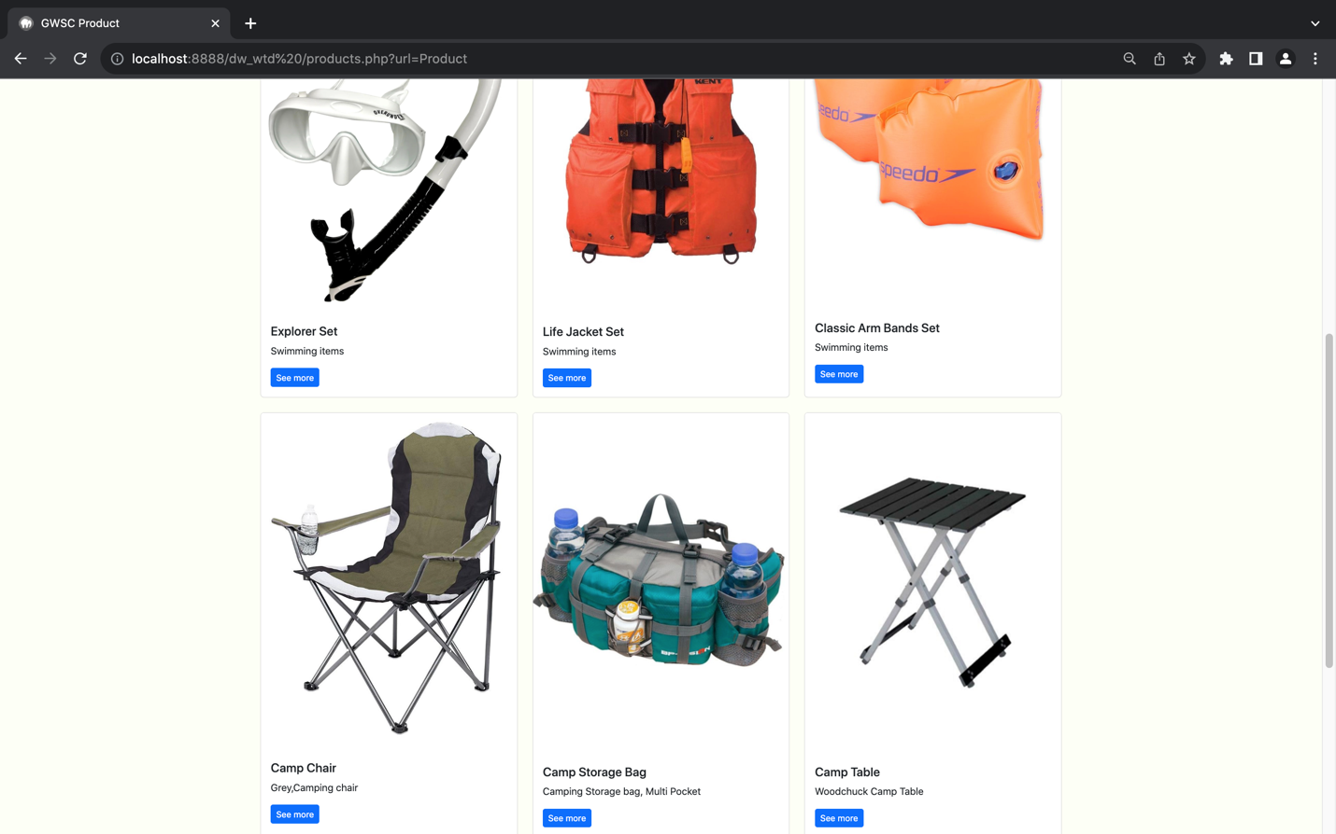

Fig 1.24 Product Page

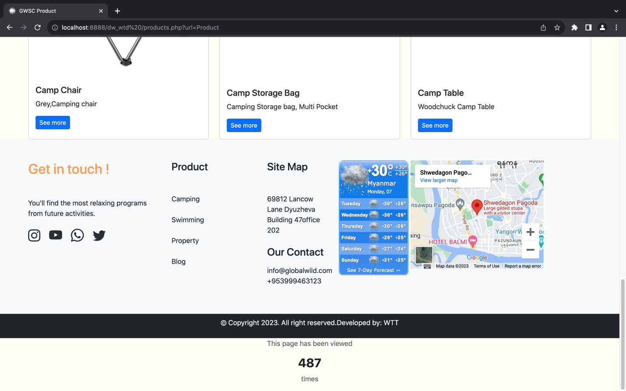

Fig 1.25 Product Page

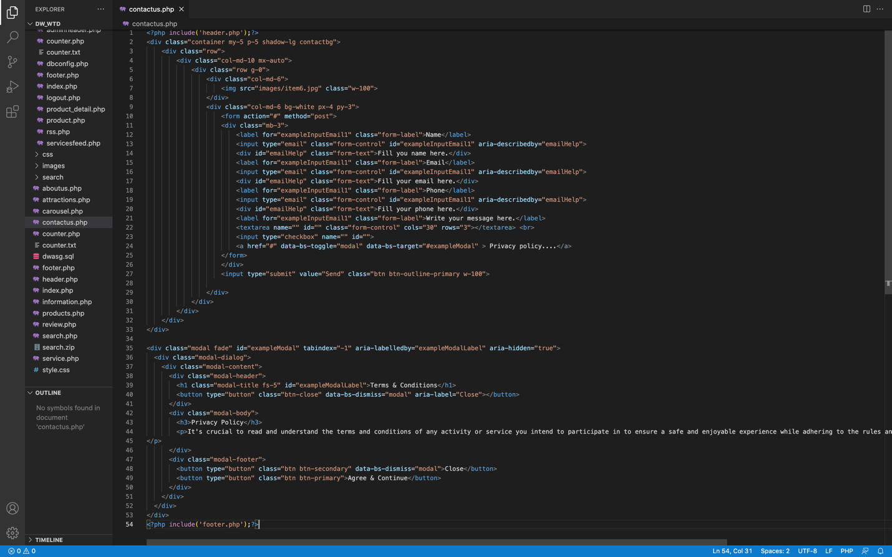

Fig 1.26 Coding ContactUs Page contactus.php

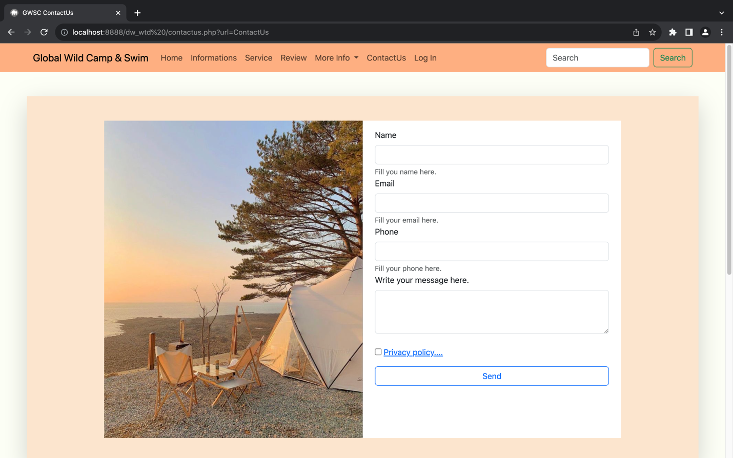

Fig 1.27 ContactUs Page

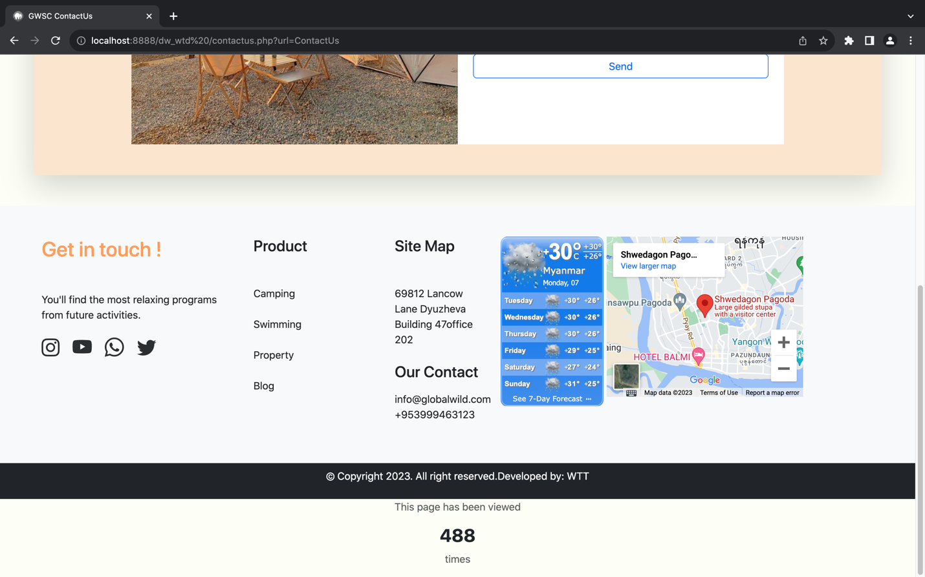

Fig 1.28 ContactUs Page

# Task2- CSS And Database

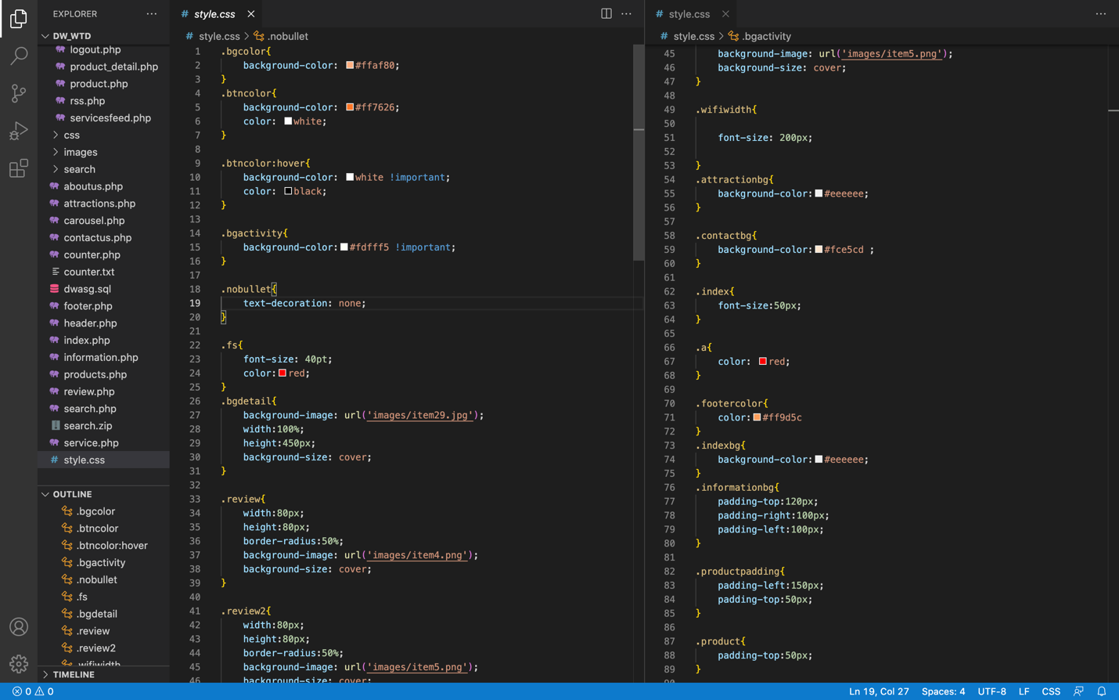

Fig 2.1 CSS coding Style.

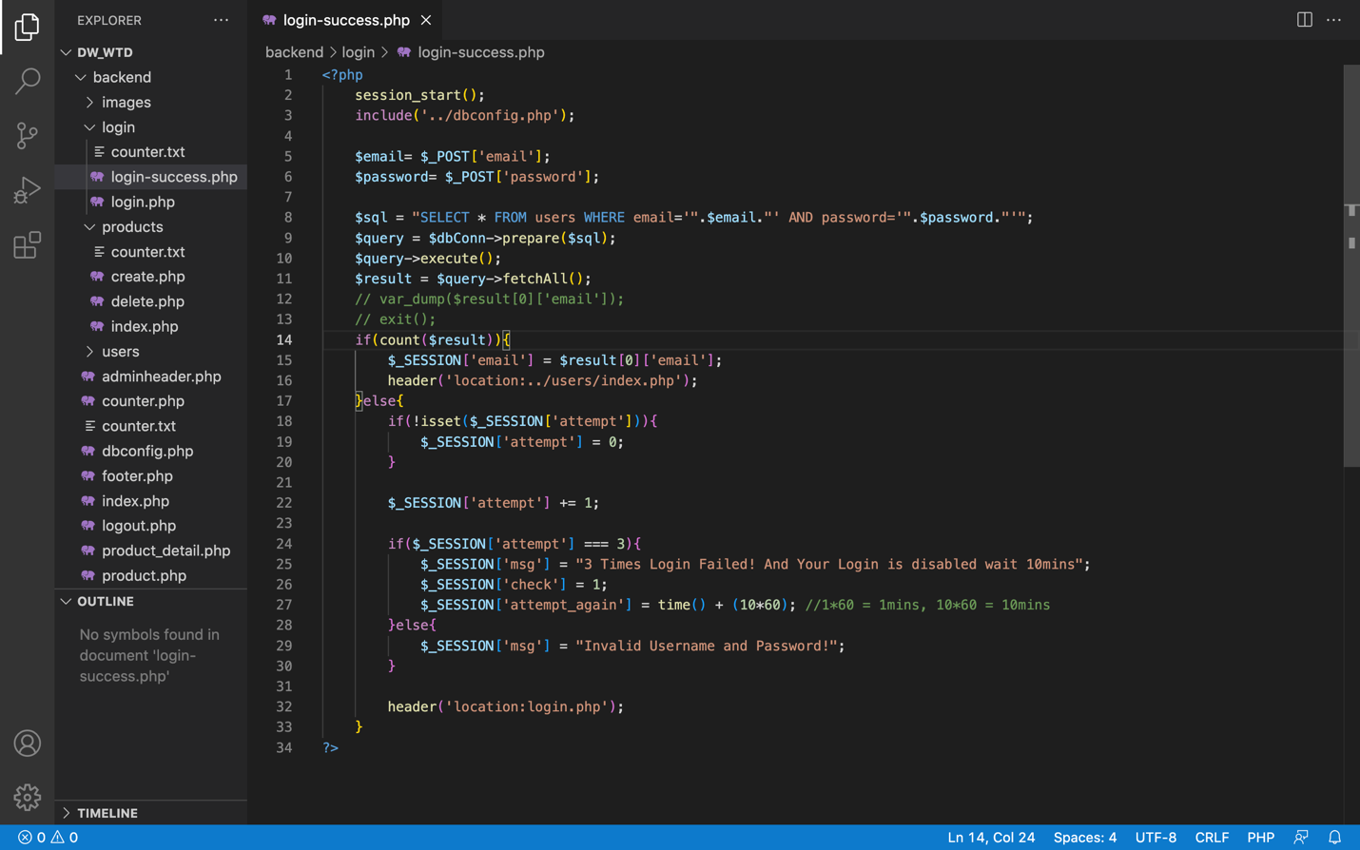

Fig 2.2 Coding login-success.php

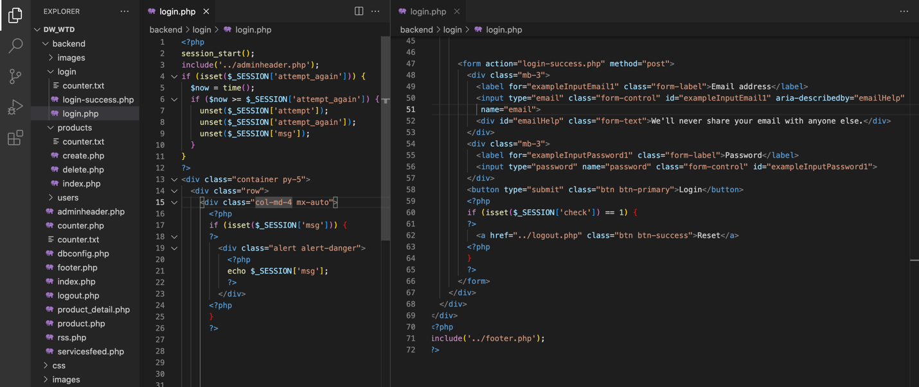

Fig 2.3 Coding login.php

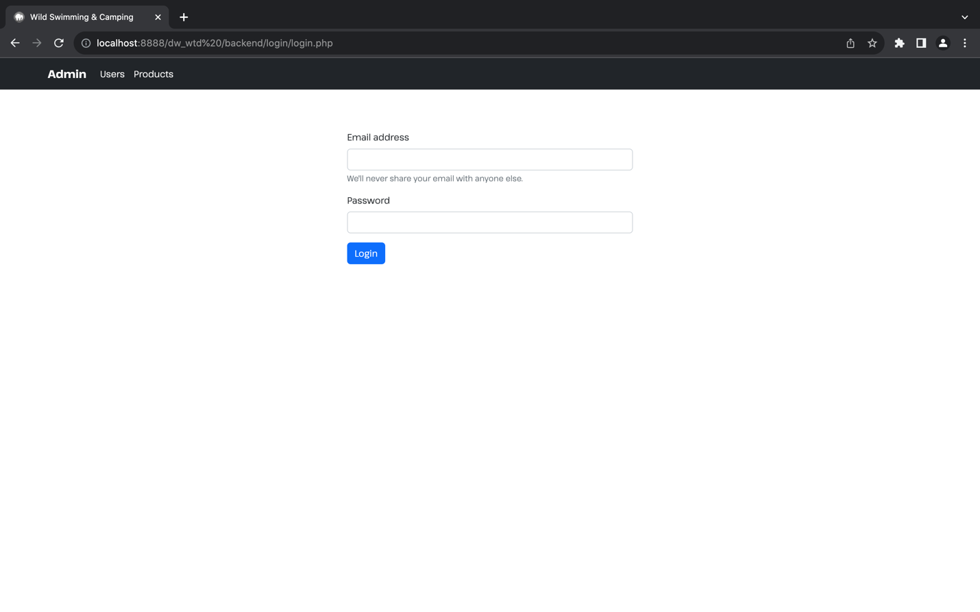

Fig 2.4 GWSC Login Page.

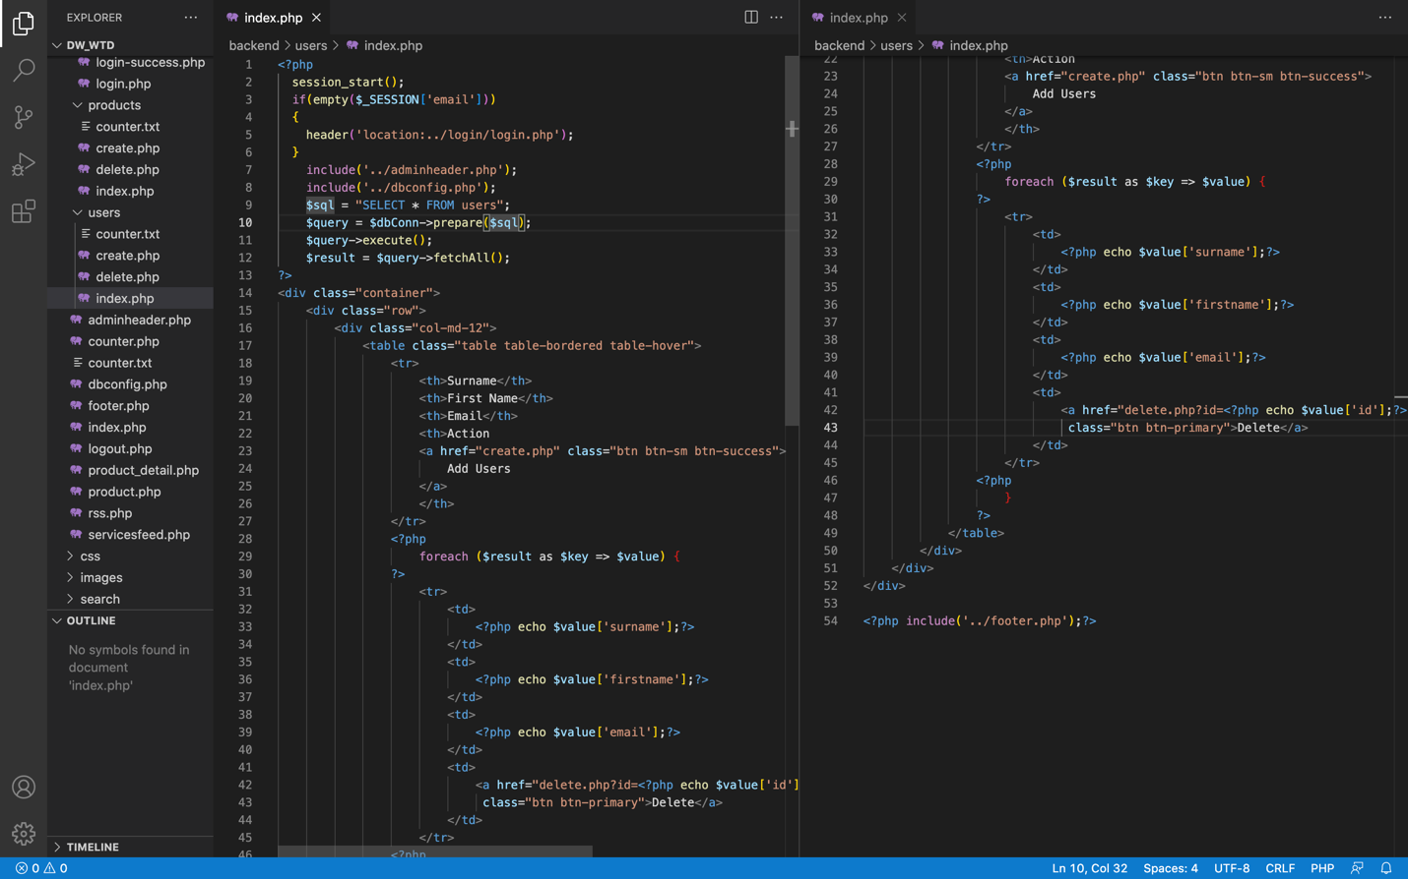

Fig 2.5 Coding user index.php

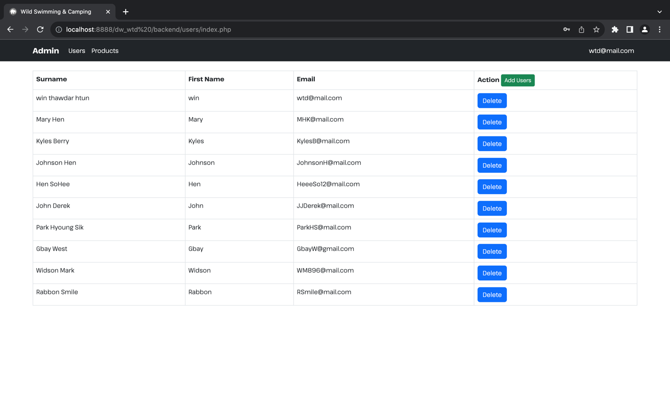

Fig 2.6 GWSC backend store personal details of each visitor.

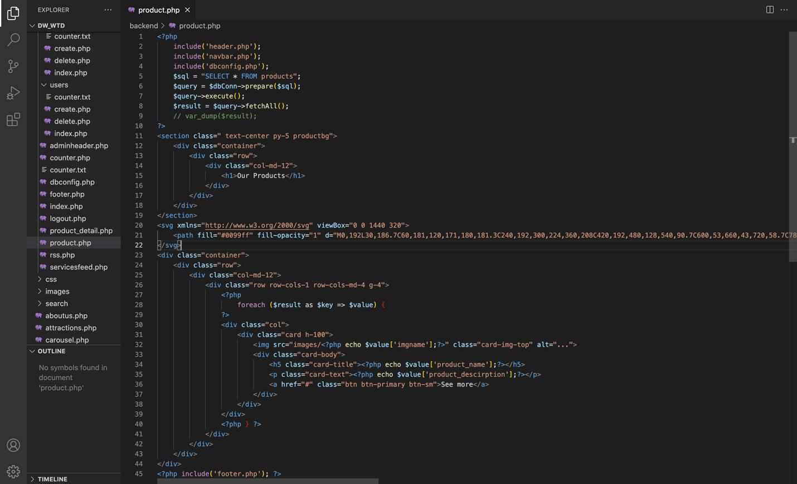

Fig 2.7 Coding GWSC product.php

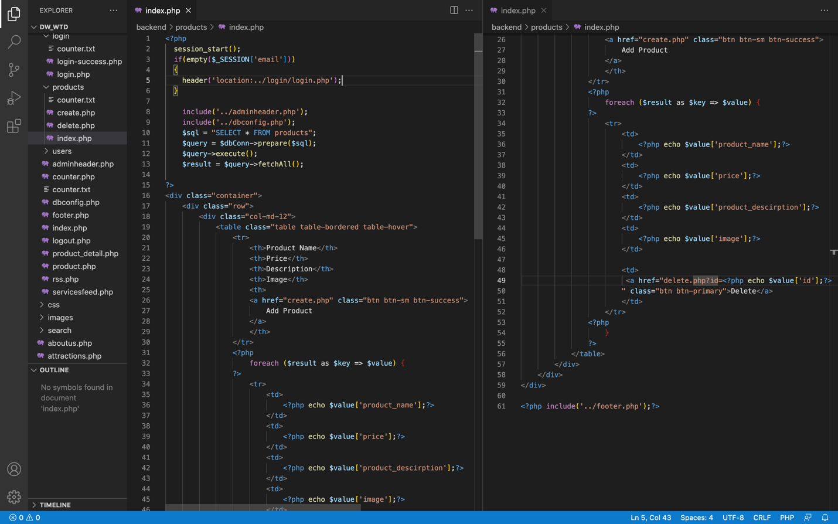

Fig 2.8 Coding GWSC product of index.php

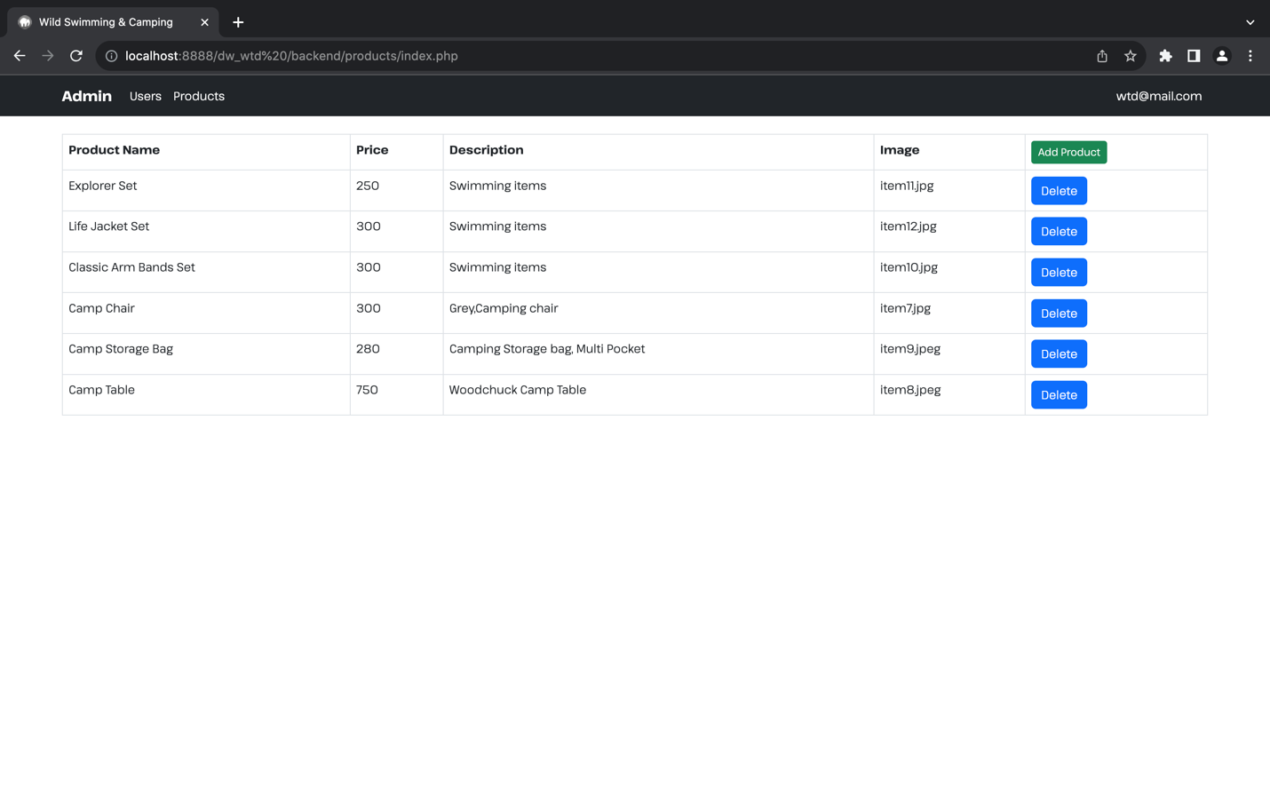

Fig 2.9 GWSC backend availability of swimming and camping products



Fig 2.10 GWSC Product Page.

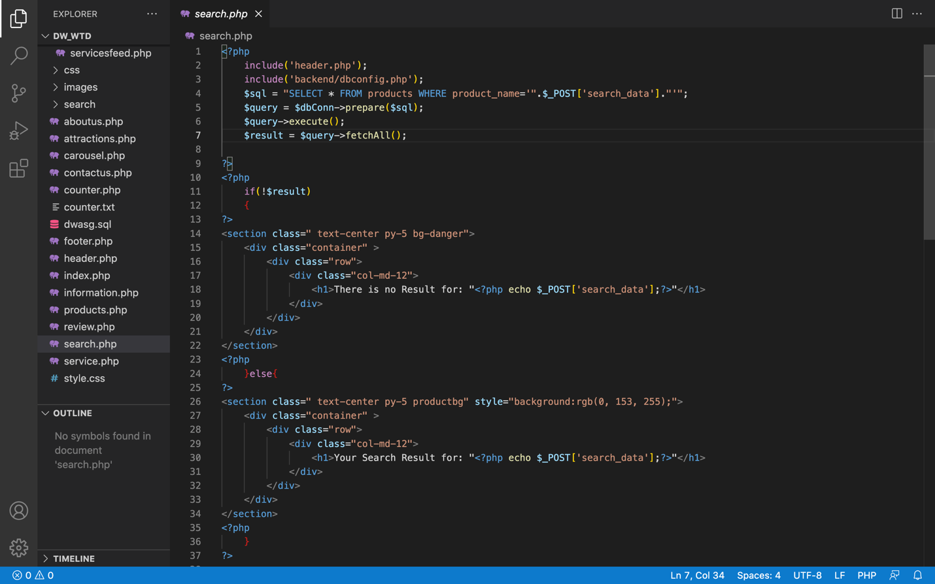

Fig 2.11 Coding Search Page search.php

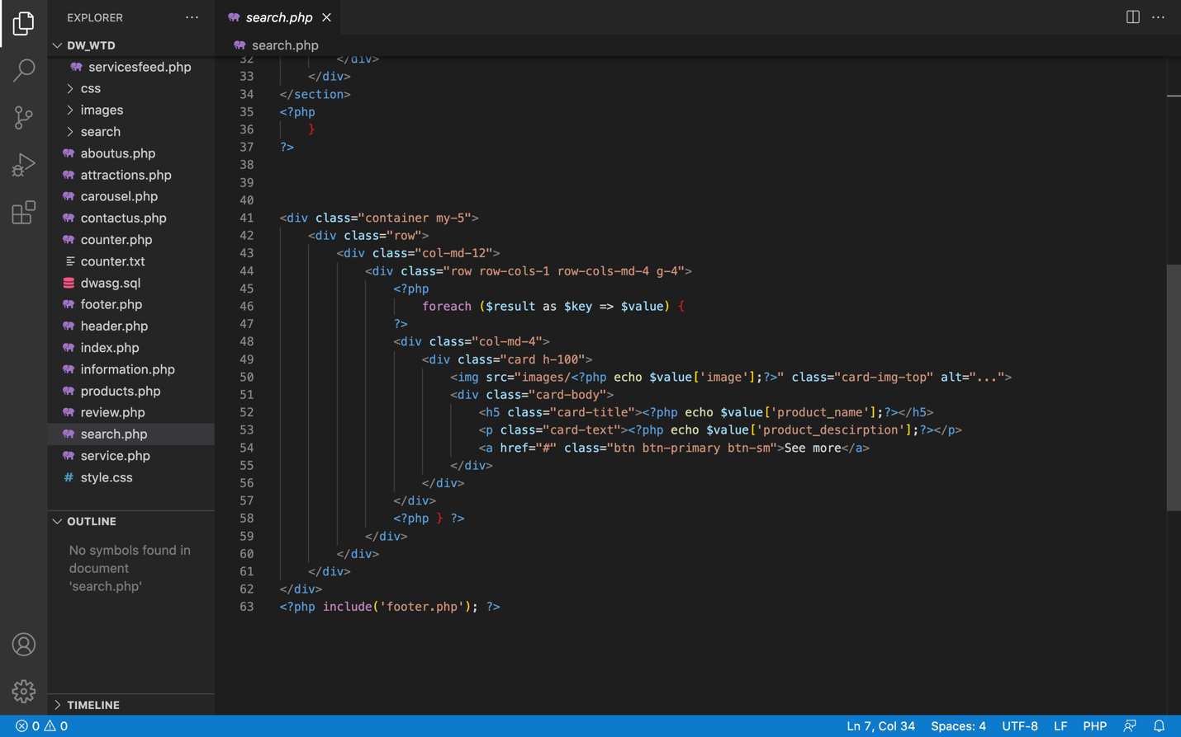

Fig 2.12 Coding Search Page search.php

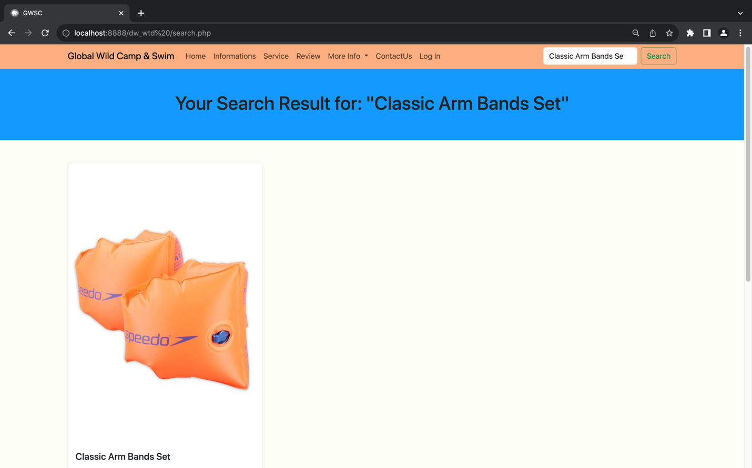

Fig 2.13 GWSC website allow search page availability of swimming and camping products.

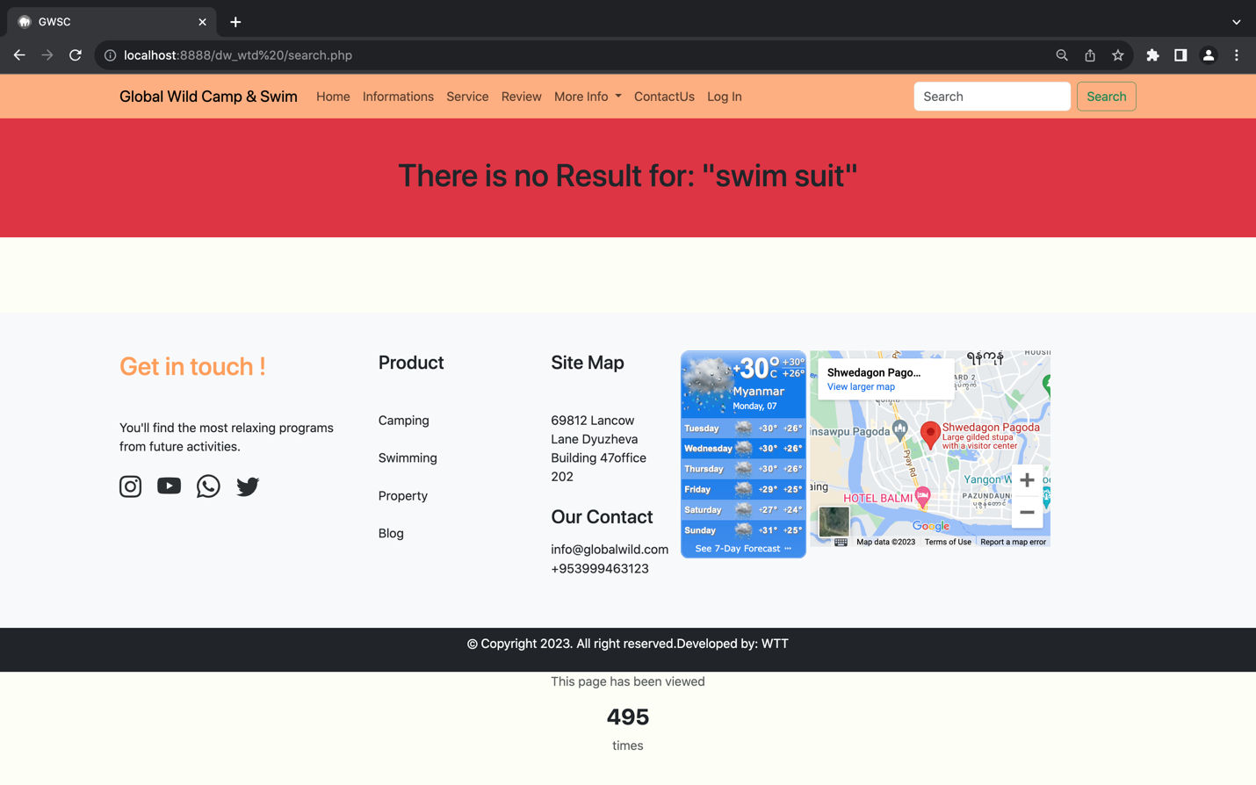

Fig 2.14 GWSC website allow search page availability of swimming and camping products.

# Task3- Critical Evaluation

Web services had developed as a key part for all business’s operations. The GWSC of web services in help of more improved functions and performances of a well-developed website.

Also, in appraisal of GWSC website where the web services provide utilizing a search page which would arise online visibility and larger gain insight in search engine showing the result of visitor preferences. The potential benefits to GWCS of web services allow user-friendly scheme and for better service of website.

In next appraisal of GWSC receiving customer reviews web services and influences on website, the attraction of it reaches out more users and soon visitors will try to visit and share their experience. This page of positive review would gain more visitors wanting to visit on GWSC only by infecting customer feedback of greater activities and services. The review page added functions of customers rating on stars as well as feedback sections given out by the customers.

These way GWSC web services had benefits on countless functionality cover web services, allow in optimization with numerous tools and services which would let GWSC website to get improved as well. A web service in hance contributes a set of flexibility and scalability for GWSC websites. It let the website to edit data or discharge functions as the GWSC website expands or wants to put more information. This would let website utilise current web services to add annual web elements which save more time and data.

## Developing HTML on GWSC website

Developing html as a foundation of a web page, supporting its contents and structures. GWSC had used html in order to format document as well as to support elements that had let us to structure our website more effectively. In hence of using tags section, header, footer the website has pointed out sectioning the parts header and footer. Hyperlinking on html whereas GWSC website enhance for navigation bar on the top of the website. This involves link tag along with href attribute, the GWSC website links onto other pages adding social media icons links on footer of the website. The sufficient use of hyperlinks can not only provide users to friendly navigation but also easy access within pages. Also used html tags like h1, h2 for heading, image slider by using div tags to enfold its slides and carousel of GWSC and then apply with css style carousel to format slider into desired propositioning especially on home page of GWSC.

## Developing CSS on GWSC website

Sincerely, developing on CSS lift up the standard of GWSC website whereas it completely changes the outlook of virtualization and format of website. GWSC used bootstrap CSS framework to enhance website. Bootstrap framework let the GWSC website in order to responsive utility on which would let user able to inspect on different devices. With its grid system the website can easily adjust user different screen size in bootstrap grid system including container, row and column whereas it ensures the website to adjust automatically on different web browsers. Moving onto external CSS where the files were linked over manual document. This way the website can put more functionality over elements also keep css file in well maintenance. The GWSC website implementing links on external CSS over every web pages it would look a lot more virtualization as well as convenient user enhancement throughout the website.

# Utilizing Web Services

GWSC website creating an efficient website letting users to provide numerous benefits and also maintain enhance overall web services and functionality of the website. The GWSC website include several utilities of web services including weather conditions, mapping locations, message boxes and more. By adding these web services, a website can affect into a wide range of data functionalities as well as enhancing user experiences and so on. The evaluation of GWSC web services utilizes listed below:

### Weather Widget

The integration of weather widget was effectively put by the page footer in order to meets the objective outlined in scenario. The page provides real time weather conditions on footer of GWSC website. By reviewing on current weather on website the user can choose the best time to get visit. Also, the user can get plan easily just by looking on website and enjoy the visit. If the user doesn’t review the weather conditions, then it might get risk by facing with heavy rain, floods or intensive temperature. This way users can get to overcome by checking on weather widget and follow relevant safety precautions.

### Location Maps

Going onto map services whereas the scenarios outline the options of adding additional web services location maps. The website did include mapping services Google Map on footer of every web page in order to accomplish location on website. The website help users point out not only the exact location of Global Wild Camping and Swimming but also the allocation of nearby local areas interest. This way users may not get lost searching for destination which cost less time and effort.

### Communication and Send messages

The website involves relevant message box whereas customers can send directly through website. And yet it effectively met the objective of adding messages form on scenario, the customer can now contact via website fulfilling the needs of visitors. The objectives adding on contact page also include check box and link to privacy and policy. By linking into privacy and policy the website assures terms and conditions of GWSC protecting customer information and privacy on visitors.

Overall, the GWSC website had effectively met the objective of the scenarios by adding on weather conditions, mapping locations, message boxes. This would help the business to succeed overall advantages as well as positive commitment on customer utilising web services.

# Task4-Reflection

## 4.1 Tools and Website Development

Through in website development the process had passed over several use of tools to contrast successful website. The website include expansion on various tools and Virtual Studio code is one of them creating a successful tool in development which it helps us browse source code repositories and make it easier changes in coding. The next successful tool developed by is MAMP which serves as an initial server environment for experimenting and debugging throughout GWSC website. Somehow in MAMP where it has some problems identifying the server settings rightly which might need technical expertise. Also, the GWSC side has server including the Laragon, an initial environment that integrated Apache server, MySQL, and PHP for delight setup and examining of website. For determining and managing GWSC website’s database, the tool used phpMyAdmin as a friendly used tool interacting with MY SQL database. There can be some error as compatibility issues within various server configurations, somehow problems where then solved developing in processes of utilizing various tools also support GWSC website to success in further more project.

## 4.2 Process and understanding website development

In concern of harmonizing our activities with the environment should be one of our priorities if we think about future generations (Pauna&Pauna, 2011). Maintaining website development is also one of local environment for future generations. That’s why in throughout the process by learning on PHP web developing language for web pages also learned in form of interaction with databases phpMyAdmin, MySQL, a web-based tool we had learned to maintain and manages website databases. This way we had learned working onto website databases and learnt how to create efficient database schemas. Also had learned in different website framework bootstrap and CSS apart from this we had thought of only normal and dull look of creating website later on learning of websites framework we did understand the point of creating visually pleasant.

## 4.3 Future Development

In future project I would like to concern of improvement on websites by learning more lessons on Dynamic Websites as well as focusing on website frameworks. In this case we would like to learn into customizing more on bootstrap style to match the similar task in the future. Also, in further projects of performance we would like to move onto optimizing codes and reduce website loading time and overall user experience. Overall, learning on Dynamic Website courses we would approach a similar task in the future with more reliable sources and ensure a smoother and more successful developing website.

# References:

[1]Livia Sangeorzan (2016) WEB DEVELOPMENT TECHNIQUES FOR APPLICATIONS AND WEBSITES [Online] Available at:

<https://www.researchgate.net/publication/325819459_WEB_DEVELOPMENT_TECHNIQUES_FOR_APPLICATIONS_AND_WEBSITES> [Accessed: 28th July 2023]

[2] Erin Glass (2020) How To Build A Website with HTML [Online] Available at:

<https://assets.digitalocean.com/books/how-to-build-a-website-with-html.pdf> [Accessed: 30th July 2023]